BRACT’s
Vishwakarma Institute of Technology, Pune
Practical Implementation Sheet
Department: CSE-AI Semester: 5 Academic Year: 2026-27
Division: E Batch: 1 Practical No: 7
Roll no:56 PRN No: 12412988 Name of Student: Arya Sawant
Subject Name : Deep Learning
1. Aim
To implement and compare image-classification models using transfer learning with VGG16, ResNet50 and EfficientNet-B0, along with an AlexNet-style CNN baseline, using TensorFlow/Keras.

2. Objectives
- Understand transfer learning using ImageNet-pretrained convolutional neural networks.
- Use a small Cat-vs-Dog subset of CIFAR-10 to reduce memory and execution time.
- Freeze the pretrained feature extraction layers and train a new binary classifier.
- Implement VGG16, ResNet50 and EfficientNet-B0 using TensorFlow/Keras.
- Implement an AlexNet-style CNN baseline because official pretrained AlexNet weights are not included in tf.keras.applications.
- Compare Accuracy, Precision, Recall and F1-Score.

3. Dataset
CIFAR-10 is used for the experiment. It contains 10 image categories. Only Cat and Dog are selected for binary classification. The experiment uses 500 images from each class for training and 100 images from each class for validation. Images are resized from 32×32 to 128×128 pixels.
- Classes: Cat and Dog
- Training images: 1,000
- Validation images: 200
- Input size: 128×128×3
- Batch size: 8
- Epochs: 2

4. Transfer Learning Theory
Transfer learning reuses knowledge learned by a neural network on a large source dataset for a different target task. Here, VGG16, ResNet50 and EfficientNet-B0 are loaded with ImageNet pretrained weights. Their convolutional base is frozen, and a new binary classification layer is added for Cat/Dog classification.
Freezing the base reduces the number of trainable parameters and makes the experiment faster and more memory efficient. The same dataset, preprocessing and evaluation metrics are used for all models to make the comparison fair.

5. Important AlexNet Note
TensorFlow/Keras does not provide an official ImageNet-pretrained AlexNet model through tf.keras.applications. Therefore, this assignment implements an AlexNet-style architecture as a baseline rather than falsely claiming that pretrained AlexNet weights are available. VGG16, ResNet50 and EfficientNet-B0 use official ImageNet pretrained weights. This distinction should be mentioned during viva if asked.
If the college specifically mandates pretrained AlexNet weights, an approved converted AlexNet checkpoint must be supplied and loaded separately. The rest of the experiment remains unchanged.

6. Models Used
Model | Type | Main idea
AlexNet | AlexNet-style baseline | Five convolutional stages followed by classification
VGG16 | ImageNet pretrained | Stacked 3×3 convolution layers
ResNet50 | ImageNet pretrained | Residual/skip connections
EfficientNet-B0 | ImageNet pretrained | Efficient compound scaling

7. Methodology
- Load CIFAR-10 using keras.datasets.cifar10.
- Select Cat and Dog classes only.
- Resize all images to 128×128.
- Create small TensorFlow tf.data input pipelines.
- Load VGG16, ResNet50 and EfficientNet-B0 with weights='imagenet'.
- Freeze their base layers.
- Add Global Average Pooling, Dropout and a sigmoid output layer.
- Train using Adam optimizer and binary cross-entropy loss.
- Evaluate using Accuracy, Precision, Recall and F1-Score.
- Run models sequentially and clear the Keras session after each model to reduce memory usage.

8. Key Implementation
base = VGG16(include_top=False, weights="imagenet", input_shape=(128,128,3))
base.trainable = False
x = base(inputs, training=False)
x = layers.GlobalAveragePooling2D()(x)
outputs = layers.Dense(1, activation="sigmoid")(x)

9. Evaluation Metrics
- Accuracy = (TP + TN) / (TP + TN + FP + FN)
- Precision = TP / (TP + FP)
- Recall = TP / (TP + FN)
- F1-Score = 2 × Precision × Recall / (Precision + Recall)
Accuracy measures overall correctness. Precision measures the correctness of positive predictions. Recall measures how many actual positive samples are detected. F1-Score balances Precision and Recall.

10. Results
Run the supplied TensorFlow program and enter the actual values printed by the program. Do not use fabricated values because the exact results depend on the software version and run.
- AlexNet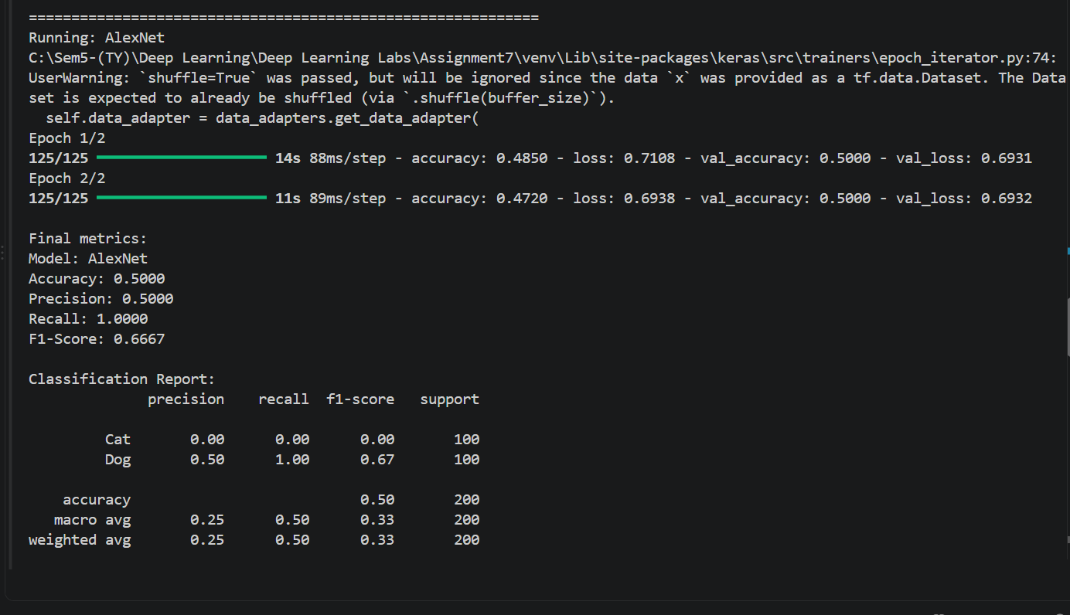
- VGG16
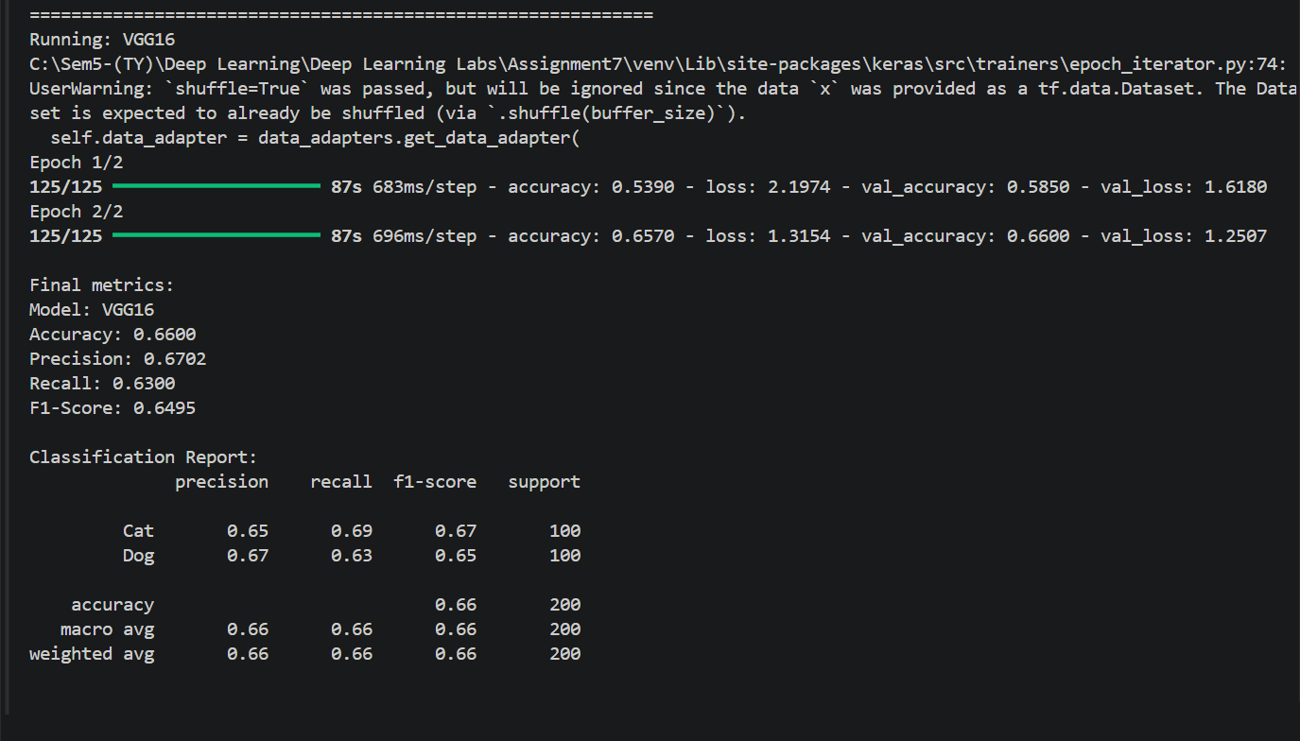
- ResNet50
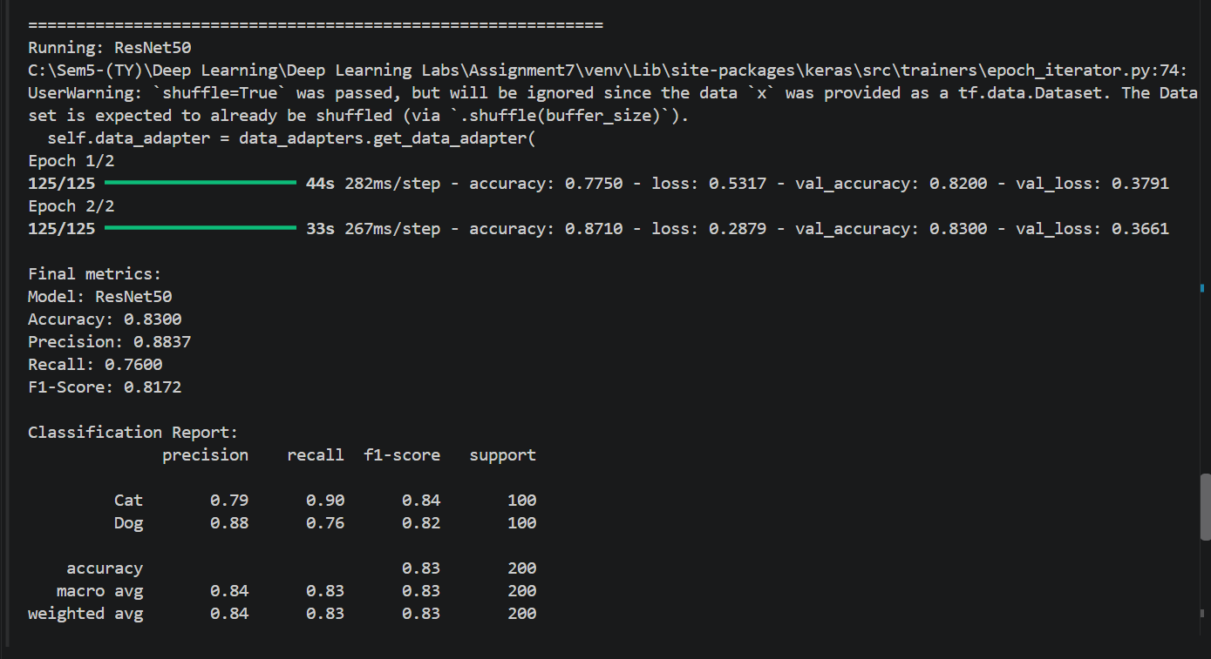
- EfficientNetB0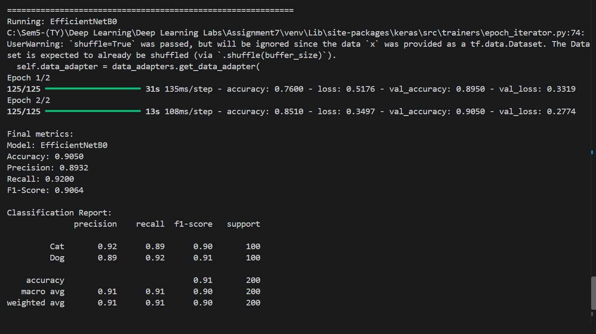
- Comparison of Models
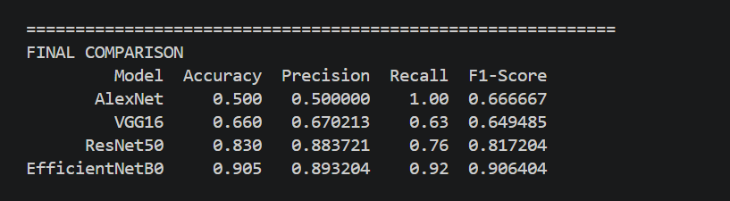
Results :
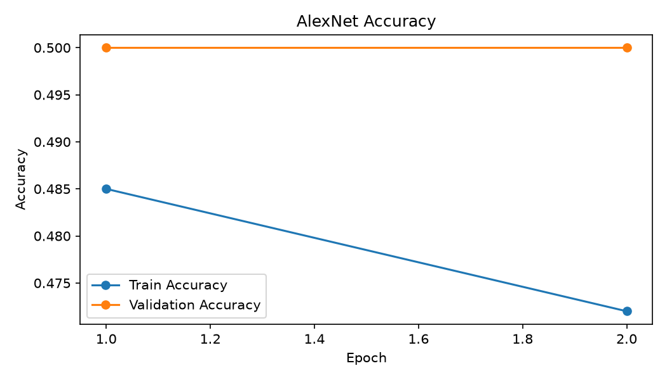
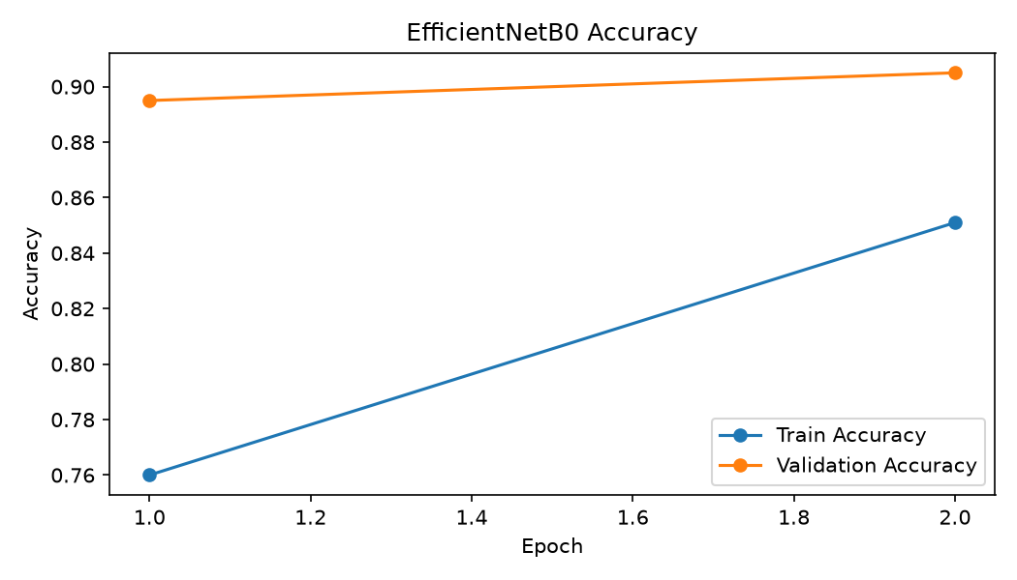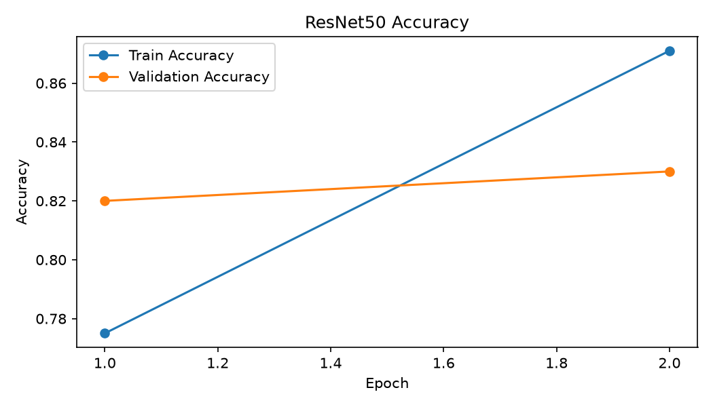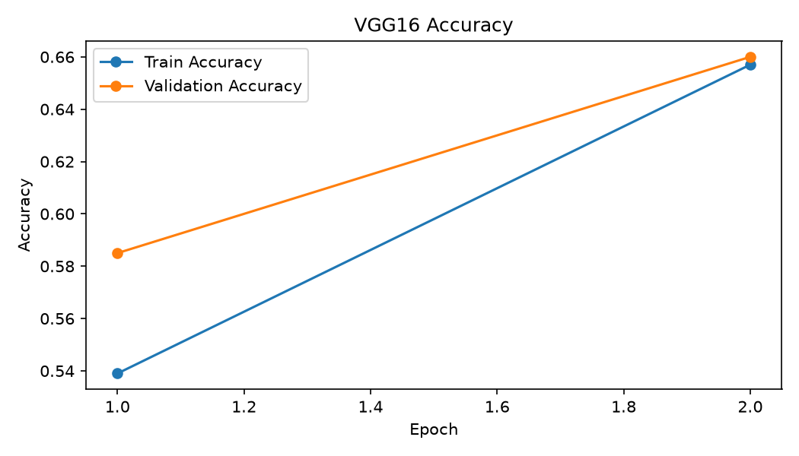
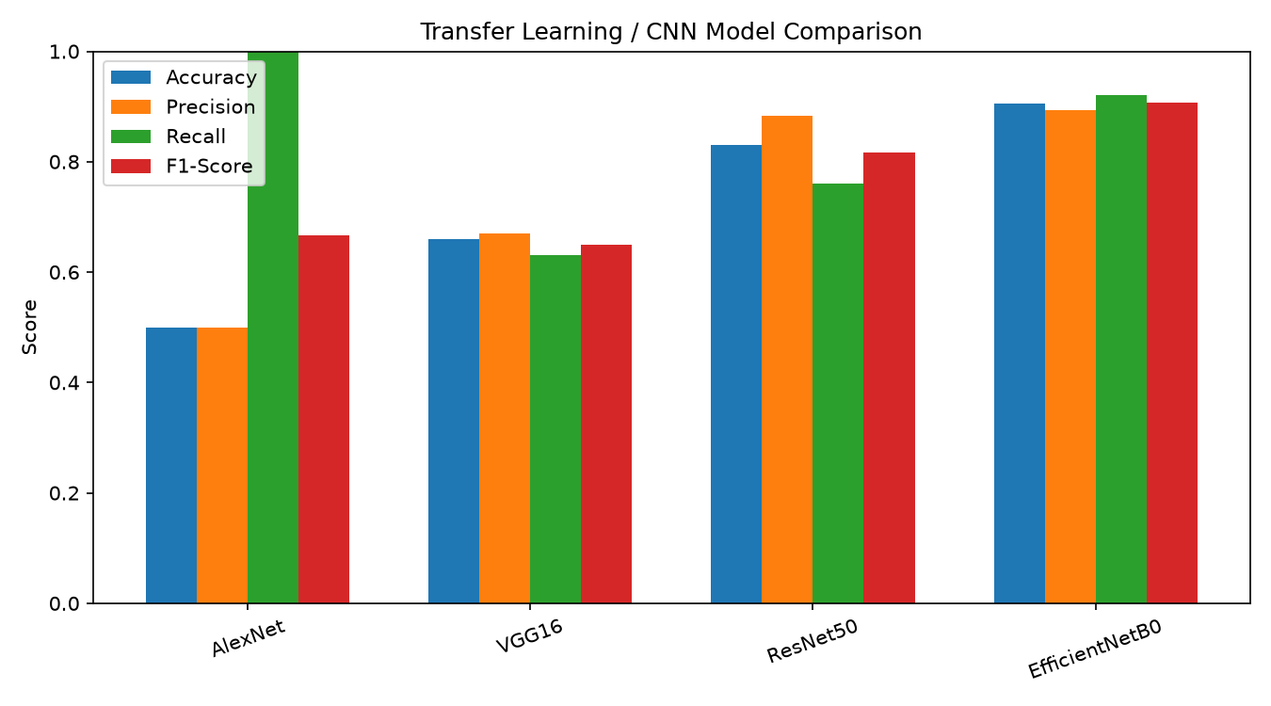

11. Result Analysis
The model having the highest validation Accuracy and F1-Score can be considered the best performer for this experiment. Precision and Recall should also be checked to understand the classification behaviour. Because the dataset is intentionally small and the experiment uses only two epochs, the results are primarily for educational comparison rather than a production benchmark.

12. Advantages
- Lower training time than training a deep CNN from scratch.
- Useful when the target dataset is small.
- Pretrained features can provide strong performance.
- Freezing layers reduces computation and memory usage.
- Different architectures can be compared under the same experimental conditions.

13. Limitations
- CIFAR-10 images are originally only 32×32 pixels.
- Only a small subset is used for low-memory execution.
- Only the classifier is trained for the pretrained models.
- AlexNet is represented by an AlexNet-style baseline in standard TensorFlow/Keras because official pretrained AlexNet weights are not provided by tf.keras.applications.
- Only two epochs are used, so this is not a fully optimized benchmark.

14. Conclusion
The image-classification experiment was implemented using TensorFlow/Keras. VGG16, ResNet50 and EfficientNet-B0 reused ImageNet pretrained features while the final binary classifier was trained for Cat-vs-Dog classification. An AlexNet-style CNN was also implemented as a baseline. Accuracy, Precision, Recall and F1-Score were used for comparison. The actual experimental results determine the final ranking of the models.

